**Lean Manufacturing Analytics - Manufacturing Sector**

GOKULNATH K & E24755

**Overview**

Lean manufacturing focuses on eliminating waste and optimizing processes to improve efficiency and product quality. In data analytics, it involves analyzing production cycles, identifying bottlenecks, and improving resource utilization. Key metrics like cycle time, defect rates, and inventory levels are monitored to enhance process flow and reduce costs. Advanced analytics, including predictive models and real-time monitoring, help anticipate maintenance needs and optimize supply chains. Overall, lean manufacturing leverages data to drive continuous improvement and maximize value with minimal resources.

**Objective**

1. Minimize production waste by identifying inefficiencies in processes.
2. Optimize resource utilization through data-driven insights on cycle times and productivity.
3. Improve product quality by monitoring and analyzing defect rates.
4. Enhance supply chain efficiency with real-time data on inventory and logistics.
5. Reduce downtime by predicting maintenance needs through machine and sensor data.
6. Streamline production scheduling by analyzing workflow and demand patterns.
7. Drive continuous improvement using key performance indicators (KPIs) and real-time monitoring.
8. Lower operational costs by identifying cost-saving opportunities in production and logistics.
9. Increase flexibility in production processes by analyzing and adjusting to demand fluctuations.
10. Maximize overall equipment effectiveness (OEE) through data-driven performance tracking.

**Assigned Task(s)**

* Lean Manufacturing Analytics - Manufacturing Sector

**Task Details**

* **Task 22:** Lean manufacturing analytics in the manufacturing sector focuses on using data to eliminate waste, optimize processes, and improve efficiency. It involves analyzing production data to enhance resource utilization, quality, and overall productivity.
* **Status:** Completed.
* **Details:**

1. Analyzed Dataset : A dataset is analyzed with lean manufacturing metrics like cycle time, OEE, defect rate, and uptime.
2. Cycle Time Analysis: A bar plot visualizes the cycle time for each product to compare efficiency.
3. OEE Trend Analysis: A line plot shows OEE trends over time, tracking equipment effectiveness.
4. Uptime and Downtime Comparison: A stacked bar plot compares uptime and downtime for each product.
5. Defect Rate Analysis: A bar plot displays the defect rate for each product, showing quality performance.
6. Matplotlib and Seaborn Usage: The code uses Matplotlib and Seaborn libraries for data visualization.

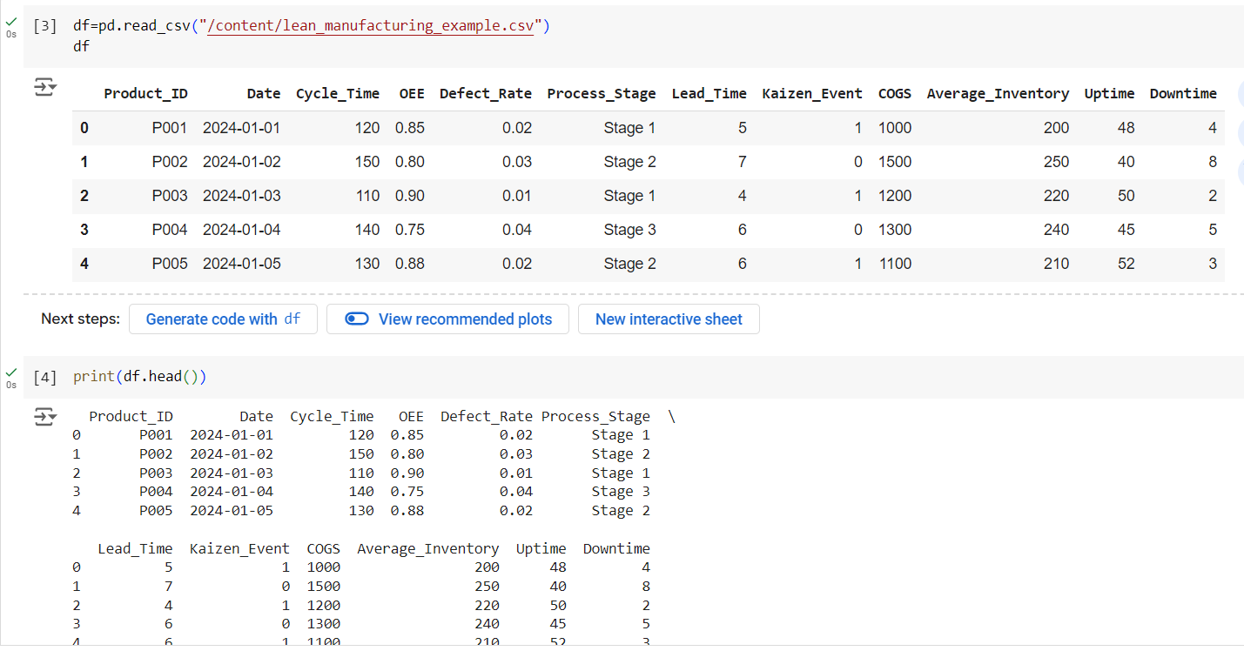

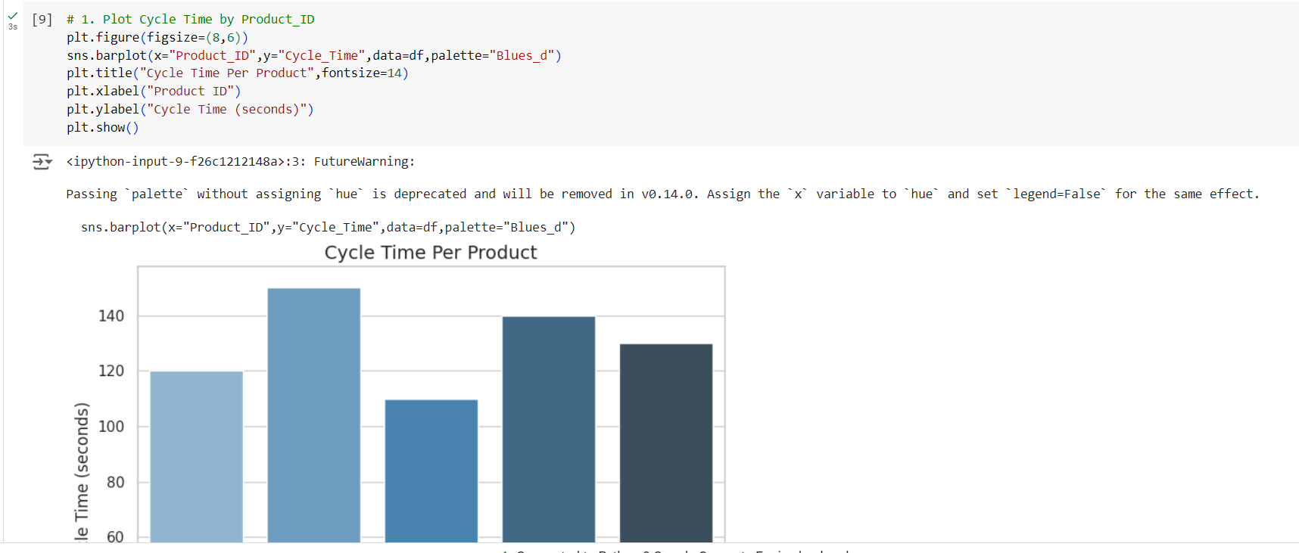

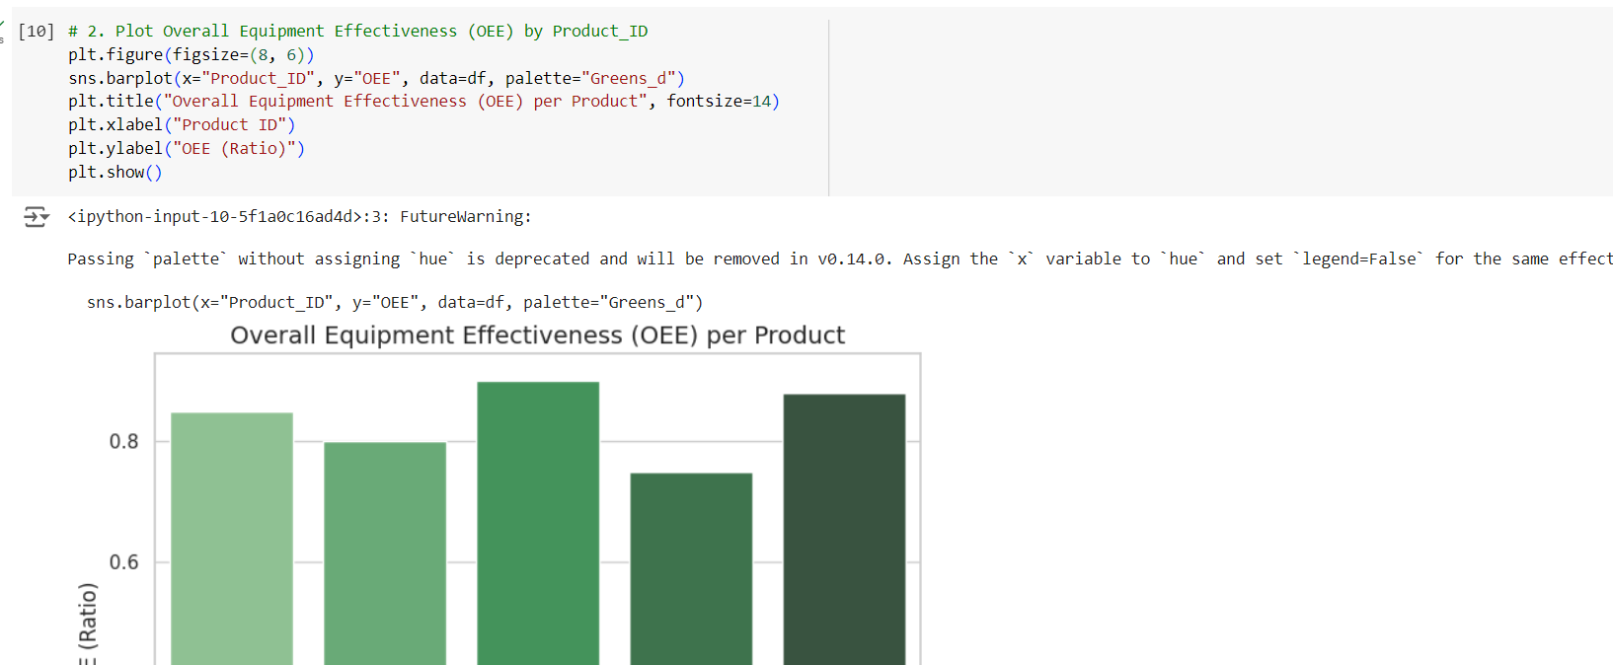

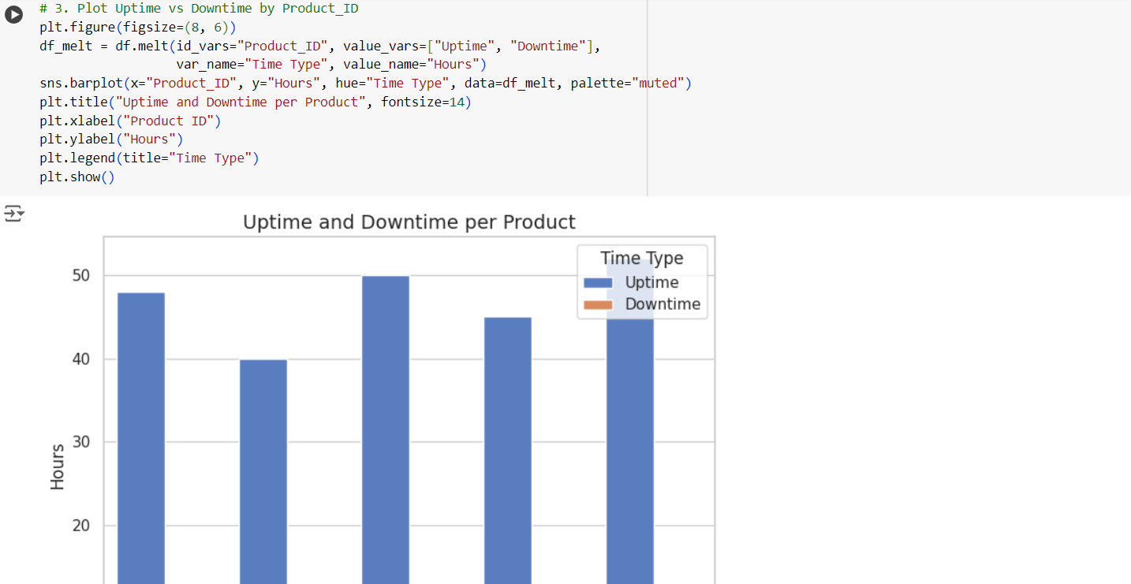

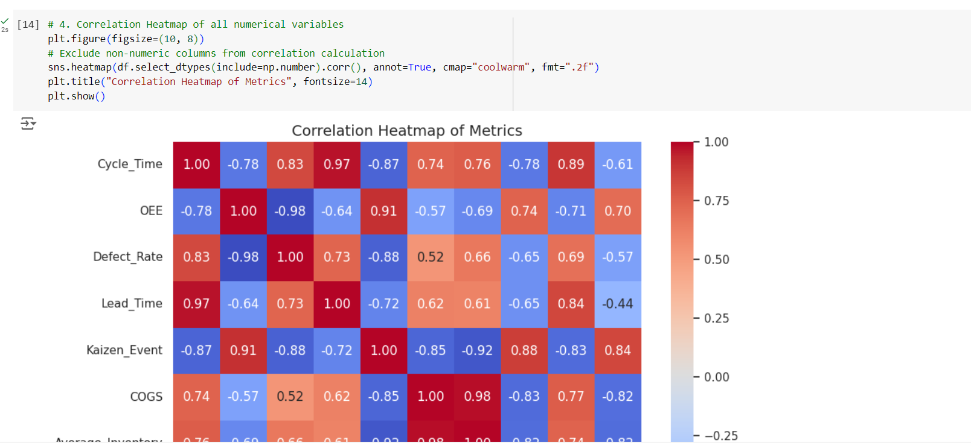

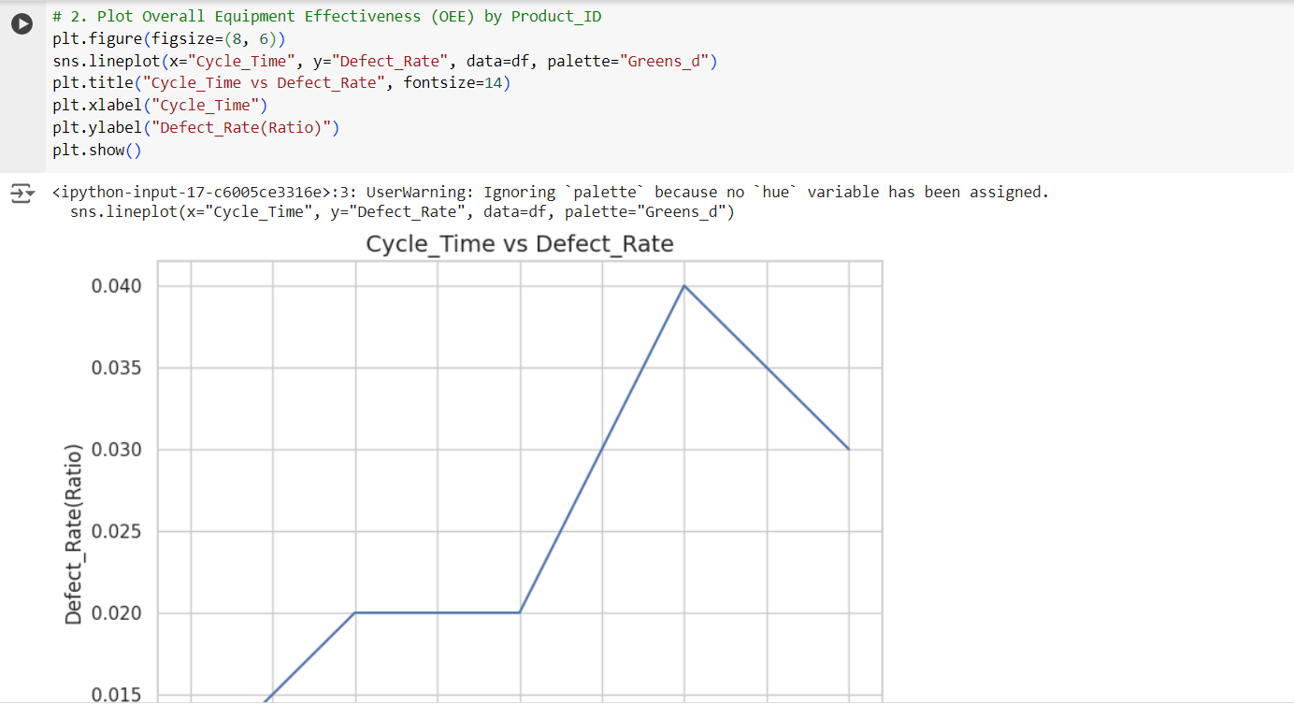

**Progress**

* **Accomplishments:**

1. Analyzed a dataset with key lean manufacturing metrics for five products.
2. Visualized cycle time using a bar plot to assess product efficiency.
3. Analyzed OEE trends over time with a line chart for equipment performance insights.
4. Compared uptime and downtime with a stacked bar plot to measure operational efficiency.
5. Highlighted defect rates using bar plots to monitor product quality.
6. Utilized Matplotlib and Seaborn for effective data visualization and reporting.

* **Metrics:**

1. Cycle Time: Measures the time taken to complete production of each product.
2. OEE (Overall Equipment Effectiveness): Assesses the efficiency and performance of equipment.
3. Defect Rate: Represents the percentage of defective products produced.
4. Process Stage: Indicates the stage of production each product is in.
5. Lead Time: Tracks the time from order to product delivery.
6. Kaizen Event: Counts the occurrence of continuous improvement events.
7. COGS (Cost of Goods Sold): Shows the cost incurred in producing each product.
8. Average Inventory: Measures the average stock level during production.
9. Uptime: The amount of time equipment is operational.
10. Downtime: The duration of equipment failure or stoppage.

**Challenges and Solutions**

* **Challenges Faced:**

1. Data Accuracy: Ensuring precise data collection for reliable metrics.
2. Visualization Complexity: Creating clear and informative visualizations for multiple metrics.
3. Handling Large Datasets: Managing and analyzing large volumes of production data.
4. Real-time Monitoring: Tracking real-time data for OEE and defect rates.
5. Process Optimization: Identifying bottlenecks from the metrics to optimize efficiency.

* **Solutions Implemented:**

1. Data Validation: Implement rigorous checks and cleaning to maintain data accuracy.
2. Simplified Visuals: Use clear and concise visualizations to communicate key insights.
3. Efficient Data Management: Use tools like Pandas for handling large datasets efficiently.
4. Real-time Dashboards: Develop live monitoring systems using real-time data integration.
5. Lean Improvements: Apply insights from metrics to continuously improve production processes.

**Next Steps**

* **Upcoming Tasks:** I can face upcoming tasks in this sector by leveraging data-driven insights to continuously improve production efficiency, reduce waste, and optimize resource allocation.
* **Goals:** To face upcoming goals, focus on setting clear objectives, utilizing advanced analytics, and adopting lean strategies to drive continuous improvement and achieve operational excellence.

**Conclusion**

* **Summary:** The analysis of lean manufacturing metrics through data visualization provides crucial insights into production efficiency, equipment performance, and product quality. Implementing these insights drives continuous improvement, operational excellence, and effective resource management.
* **Acknowledgments:** Thank you all for your attention and engagement; your interest and feedback are greatly appreciated as we strive to improve and innovate in lean manufacturing.